Wassily Kandinsky (1866-1944)
Kandinsky’s commitment to abstraction in painting and theory has attracted the attention of artists and critics throughout the twentieth century. His major manifesto Über des Geistige in der Kunst (On the Spiritual in Art) (fig.1), which described abstraction as a stimulus to a new world order, went through three editions by March of 1912. This publication as well as the establishment with the painter FRANZ MARC of the exhibition group and yearbook Der Blaue Reiter in 1911, insured the fame of his large-sized and vividly colored oils, some bearing titles such as Composition (fig. 2) and Improvisation to emphasize the relation of painting with music, then thought to be the least representational and thus the most ideal of all the arts.
Like other artists and writers of his generation who had absorbed Symbolist, theosophical, and anarchist beliefs, Kandinsky felt that he had to engage his audience in a struggle to understand his painting in order to lead them to a greater awareness of the cosmic orders. Naturalism was too descriptive of the physical world, but in 1912 he did not believe his audience, and even others artists, were ready for abstraction. Instead from 1909 onward, he chose to dematerialize biblically resonant images and to give apocalyptic or paradisiacal titles and subtitles such as Last Judgment or Garden of Love to his major works. The process through which he veiled these images is readily seen when comparing a preparatory study (fig.3) to the final oil (fig.4). Kandinsky thought these hidden images or constructions, along with contrasting lines and colours, could engage the spectator to not only stop but also to linger, even to mediate upon the work itself. If both content and form were too readable, the painting would not reflect the confusion and dichotomies of that time. By the end of 1913, he had come to believe that cosmic space, representing his vision of Paradise, could be the subject of the entire painting. Flatness had been a first step away from nature, and he wrote about his next phase of using colors and lines to move flowingly forward and backward to create what he called ‘the painterly expansion of space’. His concept of creating ‘infinite vistas’ within his canvases coincided with a burgeoning fascination among other critics and artists such as GUILLAUME APOLLONAIRE and KAZIMIR MALEVICH with the notion of the FOURTH DIMENSION as a metaphor for a new elevated consciousness that would lead humans to utopia.
The Moscow-born Kandinsky moved to Munich in 1896 to study painting. But he never lost contact with his Russian heritage and returned there during the First World War. He became a supporter of the cultural aims of the new Soviet Union, serving on committees for the reform of art education and briefly chairing the Moscow Institute of Artistic Culture. As painting came under criticism as elitist by the CONSTRUCTIVISTS, Kandinsky returned to Germany, and in 1922 WALTER GROPIUS appointed him to the faculty of Weimar’s most famous art school, the BAUHAUS. He remained with the Bauhaus as it moved from Weimar to Dessau and finally to Berlin. Shortly after the Nazis closed the school in 1933, Kandinsky immigrated to Paris, where he spent the last years of his life. Whether using amorphous colours and shapes of his pre-World War I years, or in the twenties precise geometric structures as in Several Circles (fig. 5), or biomorphic forms during the thirties and early forties, Kandinsky continued to have faith in the utopian notion of a universal language of form and colour communicating transnational and transcendental truths.

References and further Reading
Barnett, V. E. (2006-7) Kandinsky Drawings: Catalogue Raisonné, Volume One, Individual Drawings; Volume Two, Sketchbooks, London: Phillip Wilson.
Barnett, V. E. (1992-4) Kandinsky Watercolours: Catalogue Raisonné, Volume One, 1900-1921; Volume Two, 1922-44, Ithaca, NY: Cornell University Press, 1994.
Hoberg, A. (ed.). (1994) Wassily Kandinsky and Gabriele Münter, Letters and Reminiscences, 1902-1914, New York: Prestel-Verlag.
Friedel, H. (ed.) (2007) Gesammelte Schriften 1889-1916. Farbensprache, Kompositionslehre und andere unveröffentlichte Texte, Munich: Prestel-Verlag.
Lindsay, K. C., and P. Vergo (eds.) (1982) Kandinsky: Complete Writing on Art, Boston: G.K. Hall.
Long, R-C. W. (1980) Kandinsky: the Development of an Abstract Style, Oxford: Clarendon Press.
Roethel, H. K., and J. K. Benjamin. (1982-4) Kandinsky: Catalogue Raisonné of the Oil Paintings, Volume One, 1900-1915; Volume Two, 1916-1944, Ithaca, NY: Cornell University Press.
Wünsche, I. (ed) (2006) Galka E. Scheyer und Die Blaue Vier, Briefwechsel 1924-1945, Wobern, Bern: Benteli.
Zimmermann, R. (2002) Die Kunsttheorie von Wassily Kandinsky, 2 vol., Berlin: Gebr. Mann Verlag.

Paratextual Material

Fig. 1. Wassily Kandinsky, Cover of Über das Geistige in der Kunst, 3rd.ed. 1912, woodcut.
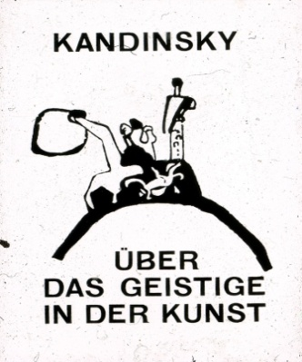
Fig. 2. Wassily Kandinsky, Composition V, 1911, oil on canvas, Neue Galerie New York. 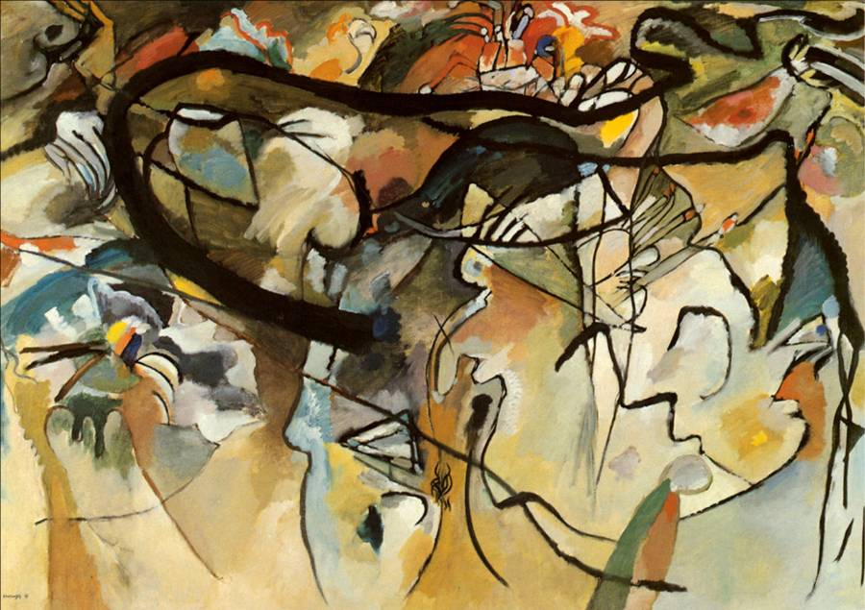

Fig. 3. Wassily Kandinsky, study for Improvisation 27 (Garden of Love II), 1911-12, watercolour, Gabriele Münter Stiftung, Städtische Galerie im Lenbachhaus, Munich. 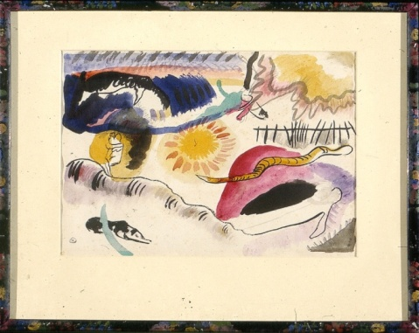

Fig. 4. Wassily Kandinsky, Improvisation 27(Garden of Love II), 1912, oil on canvas, Metropolitan Museum of Art, New York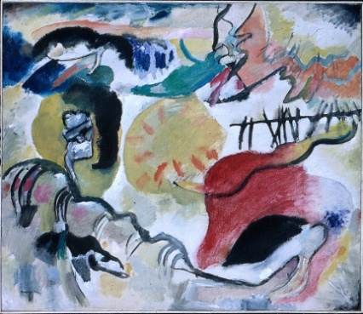

Fig. 5. Wassily Kandinsky, Several Circles, 1926, oil on canvas, Solomon R. Guggenheim Museum, New York
